Experiment No. 11
MINI PROJECT - II : GRAPH DATABASE IMPLEMENTATION & CYPHER CRUD OPERATIONS
4. Cypher Queries: Perform CRUD Operations
Implementation Environment: The PharmaTrack database is deployed on Neo4j AuraDB (Cloud Instance ID: 12a3ba9d). Implementation is executed using Cypher, Neo4j's declarative graph query language. CRUD (Create, Read, Update, Delete) operations are executed below to demonstrate full lifecycle data management, path traversal, counterfeit detection, and recall quarantine.
4.1 CREATE: Database Seeding, Nodes, and Relationships
Query Execution: Uniqueness constraints and index structures are first established to guarantee data integrity across batch IDs and facility codes. Subsequently, nodes and directional relationships are instantiated using declarative CREATE blocks:
// 1. Establish Schema Constraints
CREATE CONSTRAINT IF NOT EXISTS FOR (b:Batch) REQUIRE b.batchId IS UNIQUE;
CREATE CONSTRAINT IF NOT EXISTS FOR (s:Supplier) REQUIRE s.id IS UNIQUE;
CREATE CONSTRAINT IF NOT EXISTS FOR (m:Manufacturer) REQUIRE m.id IS UNIQUE;
// 2. Instantiate Verified Nodes
CREATE (s1:Supplier {id: 'SUP-01', name: 'Apex BioChem Ltd', country: 'Germany', certified: true})
CREATE (s2:Supplier {id: 'SUP-02', name: 'Global Solvents Co', country: 'India', certified: true})
CREATE (s3:Supplier {id: 'SUP-03', name: 'Rogue Chemical Trading', country: 'Unknown', certified: false})
CREATE (m1:Manufacturer {id: 'MFG-01', name: 'PharmaCore Labs', city: 'Basel', gmpCompliant: true})
CREATE (m2:Manufacturer {id: 'MFG-02', name: 'HealthGen Pharma', city: 'Mumbai', gmpCompliant: true})
CREATE (b1:Batch {batchId: 'BATCH-2026-A1', drugName: 'Amoxicillin 500mg', mfgDate: '2026-03-10', expiryDate: '2028-03-10', status: 'ACTIVE'})
CREATE (b2:Batch {batchId: 'BATCH-2026-B2', drugName: 'Insulin Glargine', mfgDate: '2026-05-15', expiryDate: '2027-05-15', status: 'ACTIVE'})
CREATE (b3:Batch {batchId: 'BATCH-FAKE-X9', drugName: 'Insulin Glargine', mfgDate: '2026-06-01', expiryDate: '2027-06-01', status: 'SUSPICIOUS'})
CREATE (w1:Warehouse {id: 'WH-CENTRAL', name: 'Euro Hub Logistics', city: 'Frankfurt', coldChainSupported: true})
CREATE (w2:Warehouse {id: 'WH-SOUTH', name: 'Metropolis Cold Storage', city: 'Munich', coldChainSupported: true})
CREATE (p1:Pharmacy {id: 'PHARM-01', name: 'City Central Pharmacy', city: 'Frankfurt', licenseNo: 'LIC-8821'})
CREATE (p2:Pharmacy {id: 'PHARM-02', name: 'St. Jude Hospital Pharmacy', city: 'Munich', licenseNo: 'LIC-4412'})
CREATE (p3:Pharmacy {id: 'PHARM-03', name: 'Discount Meds Online', city: 'Berlin', licenseNo: 'LIC-0000'})
CREATE (ins1:Inspector {id: 'INS-01', name: 'Dr. Elena Rostova', agency: 'European Medicines Agency'})
// 3. Connect Relationships
CREATE (s1)-[:SUPPLIED {ingredient: 'Active Amoxicillin Powder', date: '2026-02-15', lotNo: 'LOT-901'}]->(m1)
CREATE (s2)-[:SUPPLIED {ingredient: 'Biosynthetic Peptide', date: '2026-04-10', lotNo: 'LOT-554'}]->(m2)
CREATE (s3)-[:SUPPLIED {ingredient: 'Unverified Reagents', date: '2026-05-20', lotNo: 'LOT-000'}]->(m2)
CREATE (m1)-[:PRODUCED {date: '2026-03-10', totalUnits: 50000}]->(b1)
CREATE (m2)-[:PRODUCED {date: '2026-05-15', totalUnits: 20000}]->(b2)
CREATE (m1)-[:SHIPPED {dispatchDate: '2026-03-14', carrier: 'DHL Pharma', tempCelsius: 4.5}]->(w1)
CREATE (m2)-[:SHIPPED {dispatchDate: '2026-05-18', carrier: 'Kuehne+Nagel', tempCelsius: 3.8}]->(w2)
CREATE (w1)-[:STORED {shelfZone: 'Cold-A2', entryDate: '2026-03-15'}]->(b1)
CREATE (w2)-[:STORED {shelfZone: 'DeepFreeze-01', entryDate: '2026-05-19'}]->(b2)
CREATE (w1)-[:DELIVERED_TO {deliveryDate: '2026-03-20', qtyReceived: 5000}]->(p1)
CREATE (w2)-[:DELIVERED_TO {deliveryDate: '2026-05-25', qtyReceived: 3000}]->(p2)
CREATE (p1)-[:DISPENSES]->(b1)
CREATE (p2)-[:DISPENSES]->(b2)
CREATE (p3)-[:DISPENSES]->(b3) // Rogue batch with NO verified factory origin!
CREATE (ins1)-[:AUDITED {auditDate: '2026-03-12', outcome: 'PASSED', certNo: 'CERT-2026-09'}]->(b1)
CREATE (ins1)-[:AUDITED {auditDate: '2026-05-17', outcome: 'PASSED', certNo: 'CERT-2026-44'}]->(b2);

4.2 READ / QUERY: Provenance Tracing & Counterfeit Detection
Query 1 (End-to-End Batch Provenance Trace): Traces the complete physical lineage of batch 'BATCH-2026-A1' from the chemical ingredient supplier through manufacturing, warehousing, and down to the dispensing pharmacy.
MATCH (s:Supplier)-[:SUPPLIED]->(m:Manufacturer)-[:PRODUCED]->(b:Batch {batchId: 'BATCH-2026-A1'})<-[:STORED]-(w:Warehouse)-[:DELIVERED_TO]->(p:Pharmacy)
RETURN s.name AS Supplier, m.name AS Manufacturer, b.drugName AS Drug,
w.name AS Warehouse, p.name AS Pharmacy;

Query 2 (Counterfeit & Broken Chain Detection): Scans all dispensing pharmacies to identify drug batches that lack a verified manufacturing link (`WHERE NOT (:Manufacturer)-[:PRODUCED]->(b)`), immediately flagging counterfeit stock.
MATCH (p:Pharmacy)-[:DISPENSES]->(b:Batch)
WHERE NOT (:Manufacturer)-[:PRODUCED]->(b)
RETURN p.name AS SuspiciousPharmacy, b.batchId AS SuspiciousBatch,
b.drugName AS DrugName, b.status AS CurrentStatus;

Query 3 (Cold-Chain Logistics Audit): Verifies transit telemetry along SHIPPED relationships for temperature-sensitive drugs like Insulin to ensure the cold-chain threshold (< 5°C) was never breached during transit.
MATCH (m:Manufacturer)-[s:SHIPPED]->(w:Warehouse)-[:STORED]->(b:Batch {drugName: 'Insulin Glargine'})
RETURN b.batchId AS Batch, m.name AS Manufacturer, w.name AS Warehouse,
s.carrier AS Carrier, s.tempCelsius AS TransitTemperatureCelsius;

4.3 UPDATE: Property Mutation & Batch Quarantine
Query 4 (Quarantine / Recall Update): When counterfeit stock or contamination is verified, the batch status is updated to 'QUARANTINED_COUNTERFEIT' and an immutable inspection flag timestamp is added using the SET clause:
MATCH (b:Batch {batchId: 'BATCH-FAKE-X9'})
SET b.status = 'QUARANTINED_COUNTERFEIT', b.flaggedDate = '2026-10-28'
RETURN b.batchId AS Batch, b.status AS UpdatedStatus, b.flaggedDate AS FlagDate;

4.4 DELETE: Relationship & Node Cleanup
Query 5 (Rogue Relationship Deletion): Removes uncertified or blacklisted supplier connections while preserving core enterprise nodes:
MATCH (s:Supplier {id: 'SUP-03'})-[r:SUPPLIED]->()
DELETE r
RETURN count(r) AS DeletedRelationships;

5. Output Screenshots & Execution Results
Execution Visualizations: The following figures display the visual graph outputs generated in the Neo4j instance along with query result tables:
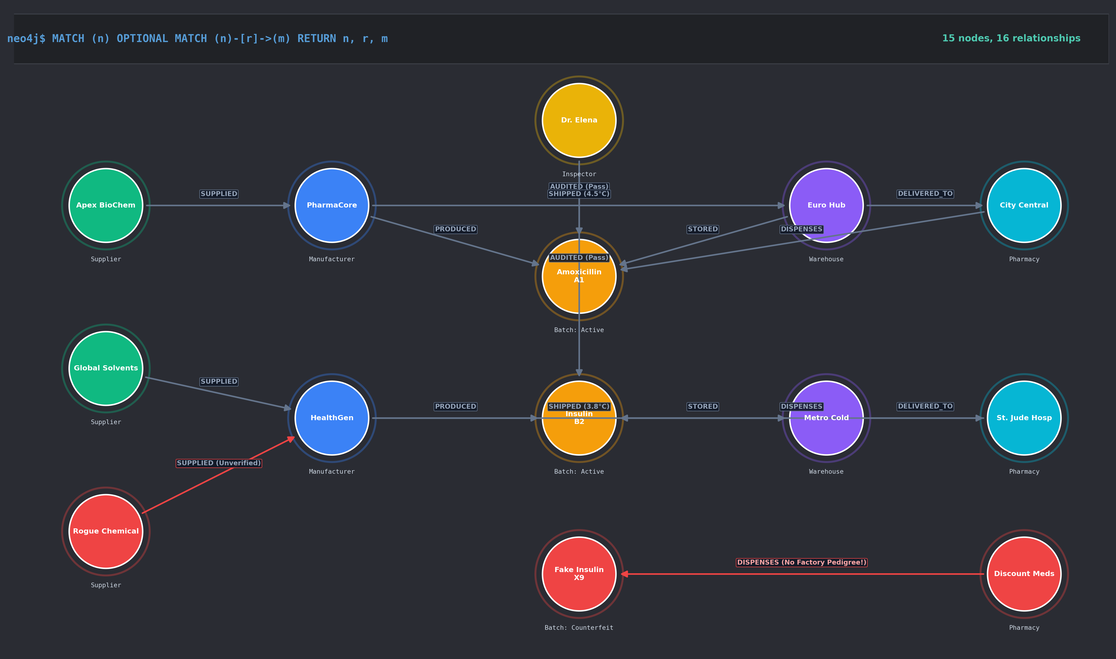
Figure 2: Full Neo4j Instance Graph Visualization (Suppliers, Batches, Warehouses, Pharmacies)
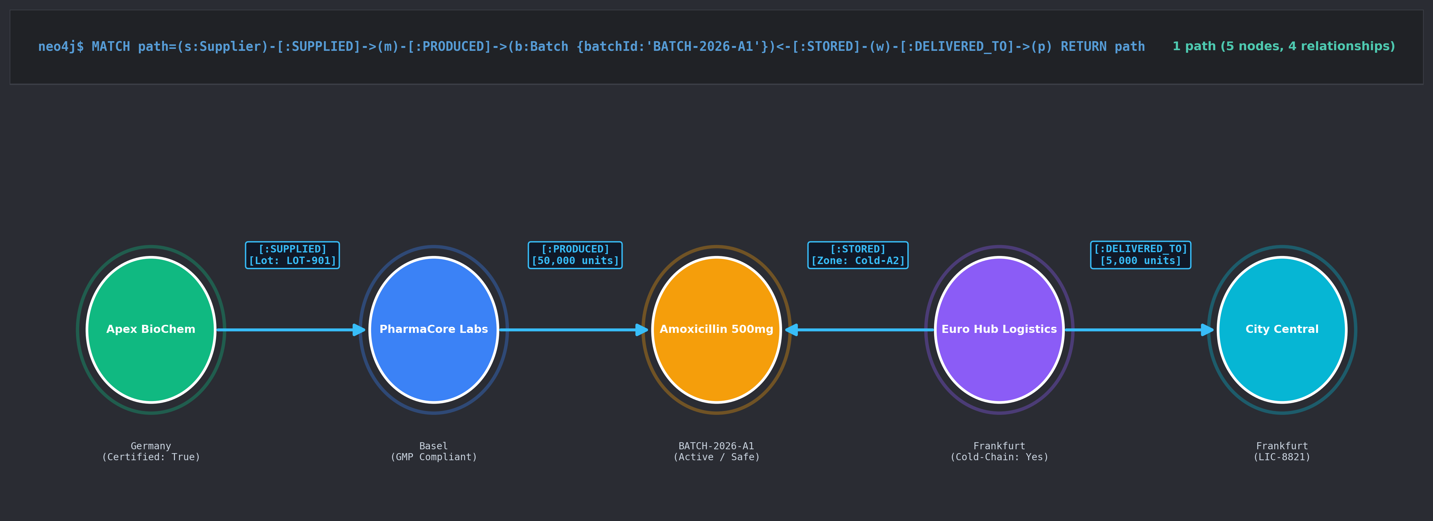
Figure 3: Query 1 Visual Traversal Result (End-to-End Batch Provenance)
5.1 Tabular Query Results
Result Table 1: Query 1 Output Table (Batch Lineage):
Supplier | Manufacturer | Drug | Warehouse | Pharmacy
Apex BioChem Ltd | PharmaCore Labs | Amoxicillin 500mg | Euro Hub Logistics | City Central Pharmacy

Result Table 2: Query 2 Output Table (Counterfeit Detection):
Suspicious Pharmacy | Suspicious Batch | Drug Name | Current Status
Discount Meds Online | BATCH-FAKE-X9 | Insulin Glargine | SUSPICIOUS

6. Observations
• Traversal Performance & Index-Free Adjacency: In Neo4j, traversing multi-hop supply chain connections occurs in O(1) time per step via direct memory pointers, avoiding relational multi-table JOINs where performance degrades exponentially (O(n^k)) as tables expand.
• Declarative Expressiveness of Cypher: Complex recursive lineage queries that require multi-level CTEs in SQL are expressed intuitively in Cypher using ASCII-art pattern matching: `(Supplier)-[:SUPPLIED]->(Manufacturer)-[:PRODUCED]->(Batch)`.
• Instant Anomaly & Counterfeit Isolation: Graph pattern negation (`WHERE NOT (m:Manufacturer)-[:PRODUCED]->(b)`) allowed instantaneous identification of illegitimate inventory lacking authentic factory genesis.
• Flexible Schema Evolution: Adding environmental metrics (transit temperature, carrier, audit certificates) directly onto relationship edges was achieved seamlessly without altering table schemas or causing database lockups.
7. Conclusion
Summary: In this experiment, the PharmaTrack graph database was successfully designed, deployed, and queried on Neo4j AuraDB. The project implemented end-to-end pharmaceutical track-and-trace capabilities, covering CRUD operations with Cypher queries. By modeling supply chain actors as nodes and logistic/regulatory interactions as first-class relationships, the system achieved rapid provenance verification, cold-chain compliance auditing, and automated counterfeit drug isolation. The results confirm that graph databases are substantially superior to traditional relational models for deeply connected, mission-critical provenance tracking.

